**Trending Memes in 2020 in India!**

The crowd is very fond of memes. The news channels and the internet is flooded with coronavirus updates, since people are spending their precious time in their homes and saving the world, half of the population is making hilarious memes on the virus spread while the other half is enjoying the same. The threat of coronavirus is weighing on each one of us but the *memers* are here for our rescue.

Surprisingly, it is mandatory in Google to use memes in all their internal emails, which reflects the affection of people towards Memes. They have become an integral part of the Social Media these days. The best part about memes is, that they are not confined for the youngsters or some specific age group, they are liked and understood by every generation. Also, they bring out the creativity of the individual. In this pandemic, when people are confined in their house and the entertainment has shifted online, memes have become of that favourite break which any individual would like to take between his/her work.

# Binge Watching!

In the very beginning of the Pandemic when people used to pass their time watching the most popular shows in India namely, Ramayan and Mahabharat. This used to be the time when the whole family used to sit together and watch.

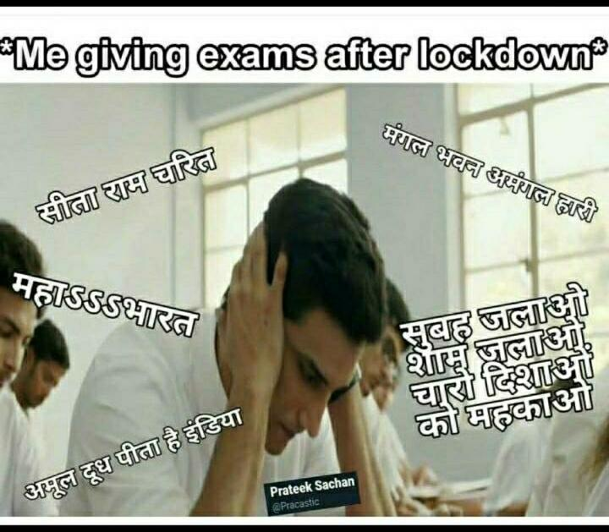

Watching these mythological shows has drastically improved our Hindi and suddenly every thought in our mind pops out having "The Ramayan Effect!"

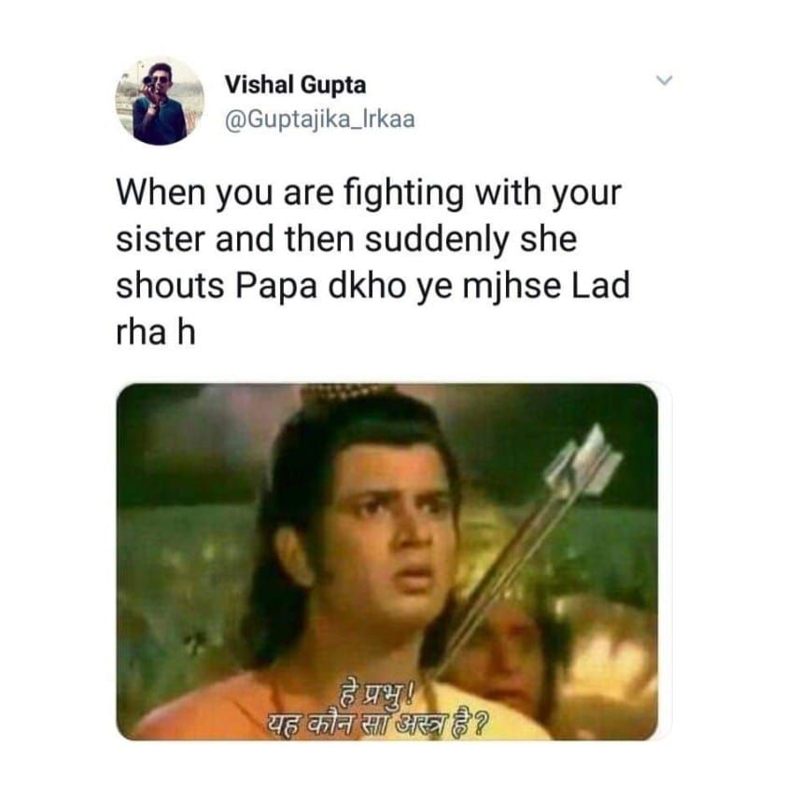

In the pandemic when most of our time goes in watching some series, movie or reading books(for the book lovers). Friends is a series which is one of the favourite series for binge-watching. People from all around the world see themselves in its characters and situations, even though Friends was premiered before some of them were even born.

# WhatsApp Image 2020-08-30 at 1.16.23 AM.jpeg

# The era of Online Classes!

After spending so much of time on binge-watching and other stuff, once the classes gets started and we get used to the new normal of being at home and attending our online classes. Memes can sometimes be used to show the inner feelings. They give us a floor to be as creative as we want. Also, it might sound dramatic but we can sometimes get out of our frustration, anger through this, which makes it even more amazing.

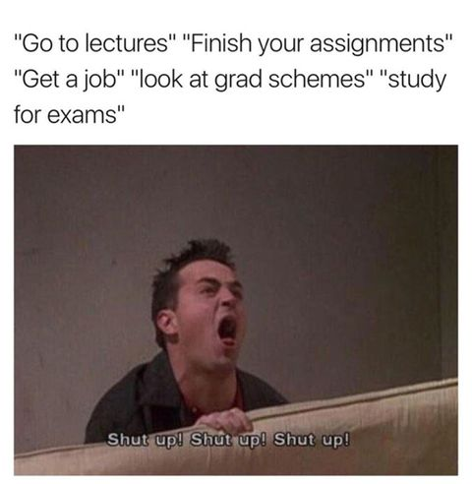

Also, with the start of everything shifting online, there is a massive increase in the use of the Internet.

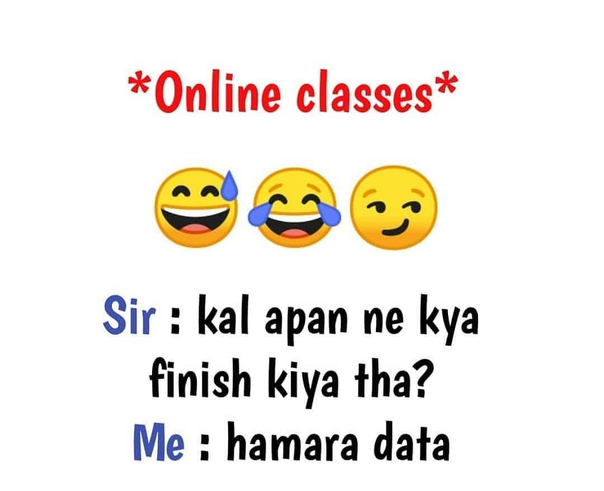

Giving exams online is the most convenient way for a student in any aspect. For those who did not connect with what I am trying to say, I mean the students are free to be in touch with anyone they want. In this technically advanced time, where the students are more equipped with technology, it is difficult to have a check on every student during an exam, like we used to have it in offline exams.

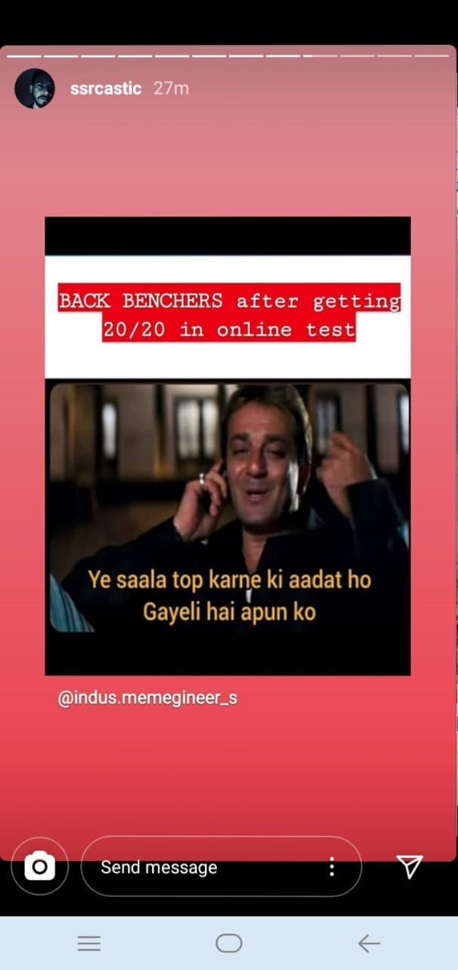

The time when we had offline exams. We all have that one friend waiting for us to finish our paper outside the examination hall. If you cannot figure out who the person is, then it is probably you!

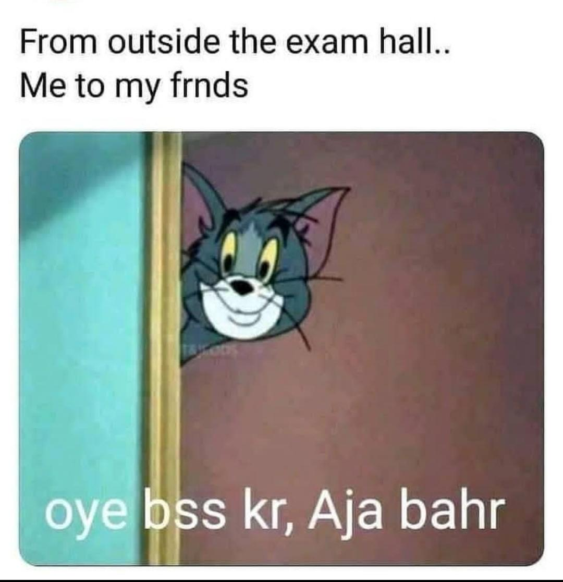

Sports is something which especially the boys love. The only way which teachers had to control the notorious crowd of the class was to blackmail them about their games period.

# WhatsApp Image 2020-09-02 at 1.32.07 AM.jpeg

# The Best Headache you can have for your life....your siblings!

Lockdown has been the time when everyone got the opportunity to spend sufficient time with their family. Siblings are the best friends we can have with us. The love-hate relationship is a unique one, especially when talking about siblings. Unconditional love forged by the closest of family bonds, yet filled with moments of competitiveness, teasing, and a weird urge to annoy one another. With that, they are the most playful companion who has made us believe their crazy theories also.

# WhatsApp Image 2020-09-01 at 10.24.12 PM.jpeg

# What's Your Plan?

We can make plans whenever we want. The best plans are made with friends (wait, I never said about executing the plans).



# Heads or Tails?

Being at home for so long, now we have a different set of conversations and topic to discuss. No prices for guessing, its "the household work".

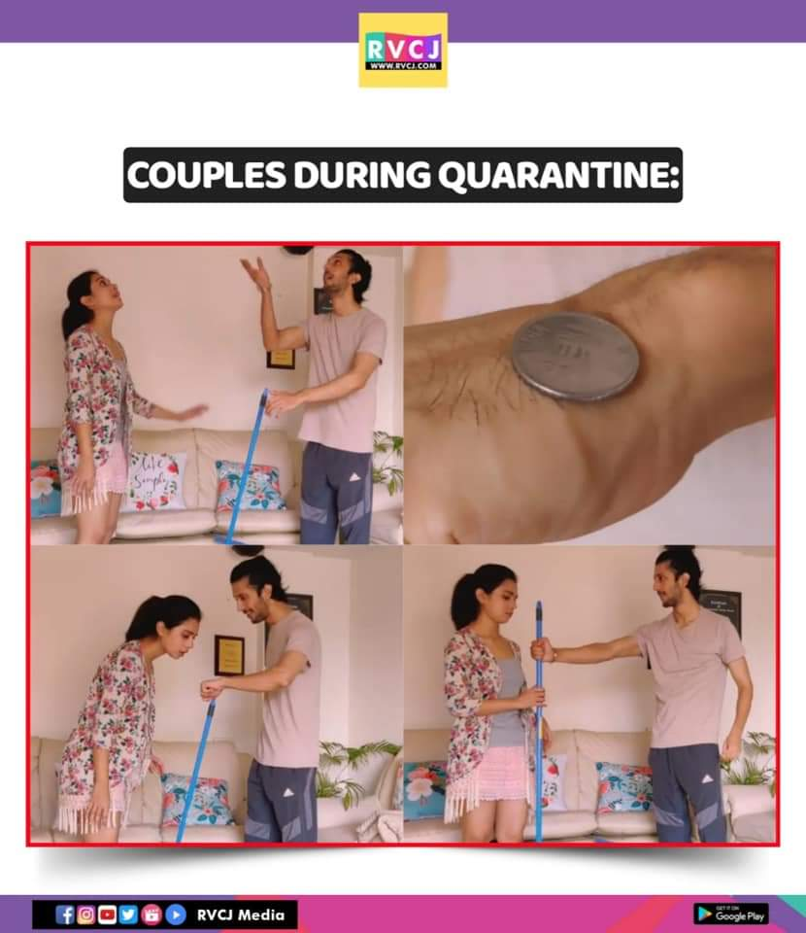

# Night Owl vs Early Birds!

People are categorized on 2 bases (Although there are many categories for a different set of observations), namely Night Owl and Early birds. All the Night Owl can understand the battle we have with our sleep throughout Night and Day.

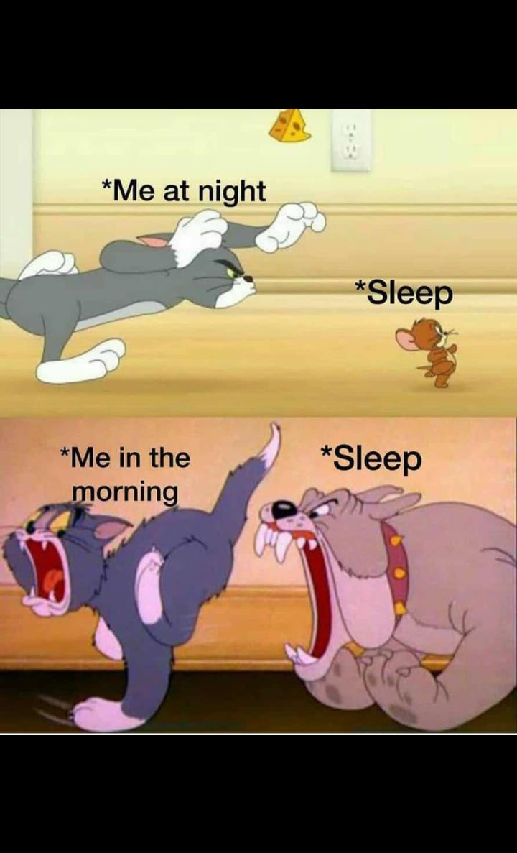

Saying that there is one more thing which all the Night Owls will agree, it is our parents advising us to wake up early. Parents have their theory to make us wake up early in the morning. But the situation we are in after waking up early is displayed very well in the meme.

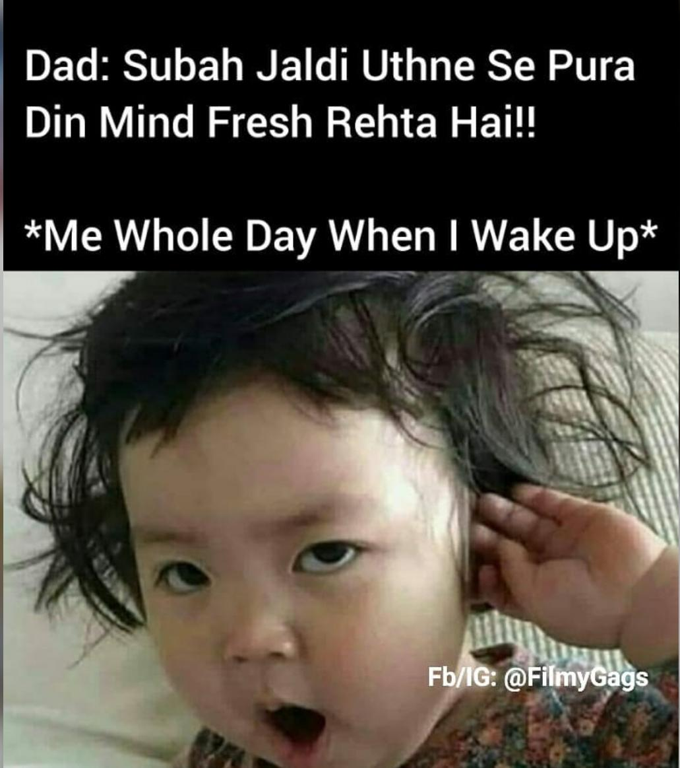

# Mai Thi?? Tum Thi?? Kaun tha??

If you had been in Indian cyberspace in the past few days, you surely know what we are talking about. The viral video in which Kokilaben's dialogues have been turned into a rap song has also triggered a hilarious meme-fest online.

It all started with Singer-music producer Yashraj Mukhate, who used a popular scene from Star Plus show "Saath Nibhana Sathiya". It started as an addictive song that people could not stop listening to.

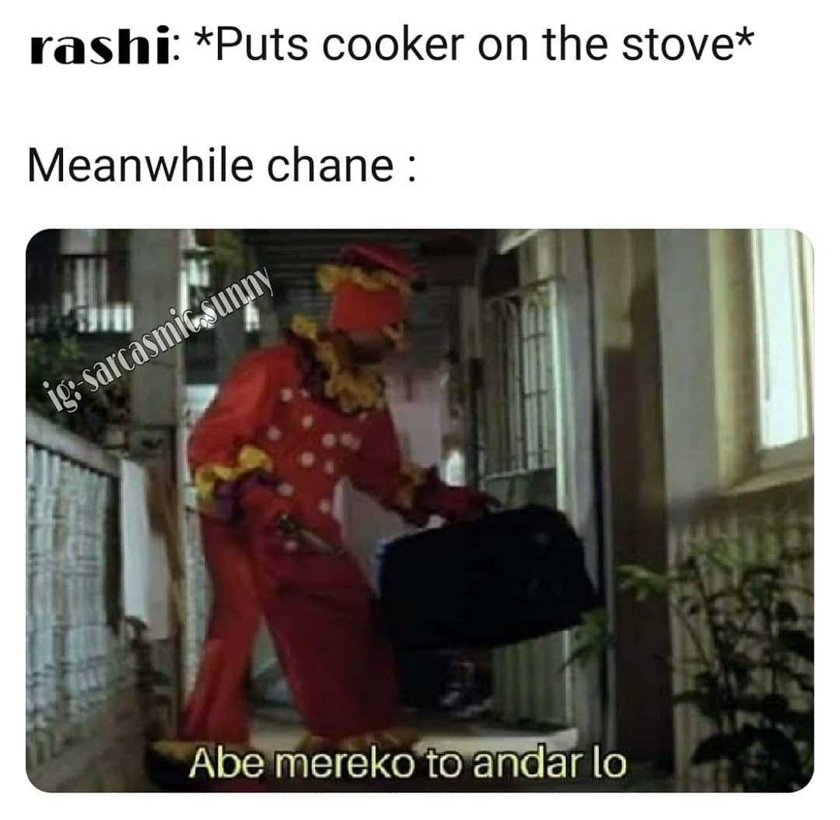

And when a coder turns into a memer, the same topic has something like this as a meme.

PS: Only coders can understand what it means!

# WhatsApp Image 2020-09-02 at 12.22.46 AM.jpeg

# Did you say Binod??

You must have heard name Binod all over the internet, but do you know how he came into the limelight?

BINOD was a YouTube comment that became a viral meme in India in August 2020. It originated from a YouTube comment by a user named Binod Tharu, that had not uploaded any videos and was only adding his first name in the comment section of YouTube videos.

Every famous YouTuber who does a live stream, their comments sections are flooded randomly with the name Binod. The only thing the nation wants to know right now is who is Binod?

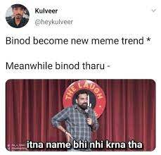

Now with memes, we can hilariously express every mood of ours. Indeed, these memes have already become an inseparable emotion for all of us. So keep sharing such hilarious memes and spreading positive cum funny vibes. To keep ourselves happy and have the best short break, we can say, "A meme a day keeps sadness away!"